
CosmiCode
Artificial Intelligence
Internship Module
Week 5: Neural Networks &amp; Deep Learning (Advanced)

Submitted To: Zarwish – CosmiCode HR
Submitted By: Haris Ali
Subject: Artificial Intelligence
Internship Module: Week 5
Date of Submission: 05/07/2025

Objective: Get hands-on with neural networks using TensorFlow/Keras.
TASK 1:
Install TensorFlow and Keras. Build your first Perceptron model for binary classification.
SOLUTION:
First I install the required libraries then I make a code,
import numpy as np
from tensorflow.keras.models import Sequential
from tensorflow.keras.layers import Dense
from sklearn.datasets import make_classification
from sklearn.model_selection import train_test_split
from sklearn.metrics import accuracy_score

X, y = make_classification(n_samples=1000, n_features=2, n_informative=2,
n_redundant=0, n_clusters_per_class=1, random_state=42)

X_train, X_test, y_train, y_test = train_test_split(X, y, test_size=0.2, random_state=42)

model = Sequential()
model.add(Dense(1, activation='sigmoid', input_dim=2))
model.compile(optimizer='adam', loss='binary_crossentropy', metrics=['accuracy'])
model.fit(X_train, y_train, epochs=50, batch_size=10, verbose=1)

loss, accuracy = model.evaluate(X_test, y_test)
print(f"\nTest Accuracy: {accuracy:.2f}")

predictions = model.predict(X_test)
predictions = (predictions > 0.5).astype(int)
print("Final Accuracy:", accuracy_score(y_test, predictions))

OUTPUT:
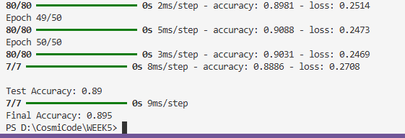

TASK 2:
Implement a Multi-Layer Perceptron (MLP) for the MNIST handwritten digit dataset.
SOLUTION:
import tensorflow as tf
from tensorflow.keras.models import Sequential
from tensorflow.keras.layers import Dense, Flatten
from tensorflow.keras.datasets import mnist
from tensorflow.keras.utils import to_categorical

(X_train, y_train), (X_test, y_test) = mnist.load_data()

X_train = X_train.astype('float32') / 255
X_test = X_test.astype('float32') / 255

y_train = to_categorical(y_train, 10)
y_test = to_categorical(y_test, 10)

model = Sequential()
model.add(Flatten(input_shape=(28, 28)))
model.add(Dense(128, activation='relu'))
model.add(Dense(64, activation='relu'))
model.add(Dense(10, activation='softmax'))

model.compile(optimizer='adam', loss='categorical_crossentropy', metrics=['accuracy'])

model.fit(X_train, y_train, epochs=10, batch_size=128, verbose=1)

loss, accuracy = model.evaluate(X_test, y_test)
print(f"\nTest Accuracy: {accuracy:.2f}")

OUTPUT:
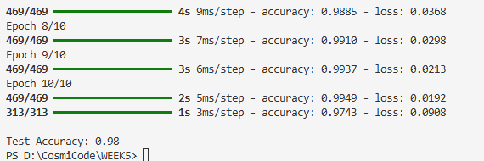

TASK 3:
Visualize model accuracy and loss graphs using Matplotlib.
SOLUTION:
import tensorflow as tf
from tensorflow.keras.models import Sequential
from tensorflow.keras.layers import Dense, Flatten
from tensorflow.keras.datasets import mnist
from tensorflow.keras.utils import to_categorical
import matplotlib.pyplot as plt

(X_train, y_train), (X_test, y_test) = mnist.load_data()

X_train = X_train.astype('float32') / 255
X_test = X_test.astype('float32') / 255

y_train = to_categorical(y_train, 10)
y_test = to_categorical(y_test, 10)

model = Sequential()
model.add(Flatten(input_shape=(28, 28)))
model.add(Dense(128, activation='relu'))
model.add(Dense(64, activation='relu'))
model.add(Dense(10, activation='softmax'))

model.compile(optimizer='adam', loss='categorical_crossentropy', metrics=['accuracy'])

history = model.fit(X_train, y_train, epochs=10, batch_size=128, verbose=1, validation_split=0.2)

plt.plot(history.history['accuracy'], label='Training Accuracy')
plt.plot(history.history['val_accuracy'], label='Validation Accuracy')
plt.title('Model Accuracy')
plt.ylabel('Accuracy')
plt.xlabel('Epoch')
plt.legend()
plt.show()

plt.plot(history.history['loss'], label='Training Loss')
plt.plot(history.history['val_loss'], label='Validation Loss')
plt.title('Model Loss')
plt.ylabel('Loss')
plt.xlabel('Epoch')
plt.legend()
plt.show()

OUTPUT:
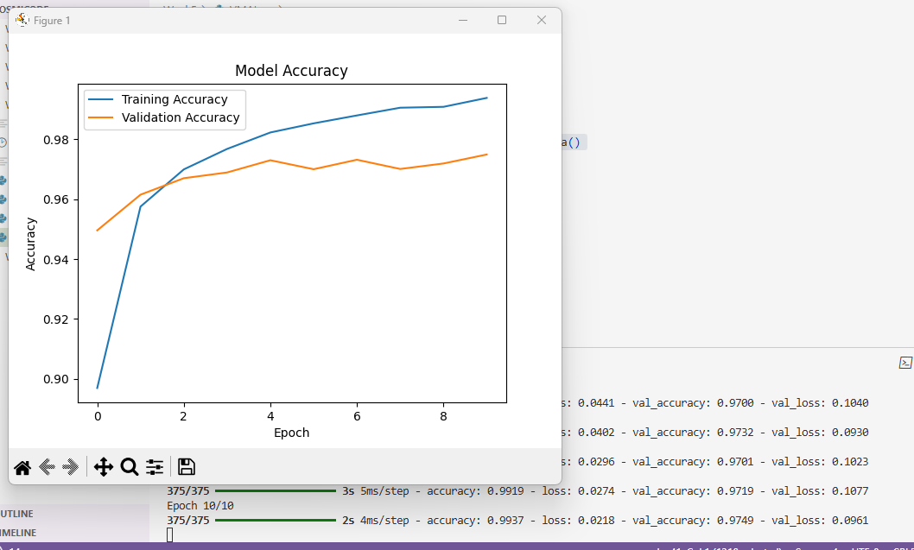
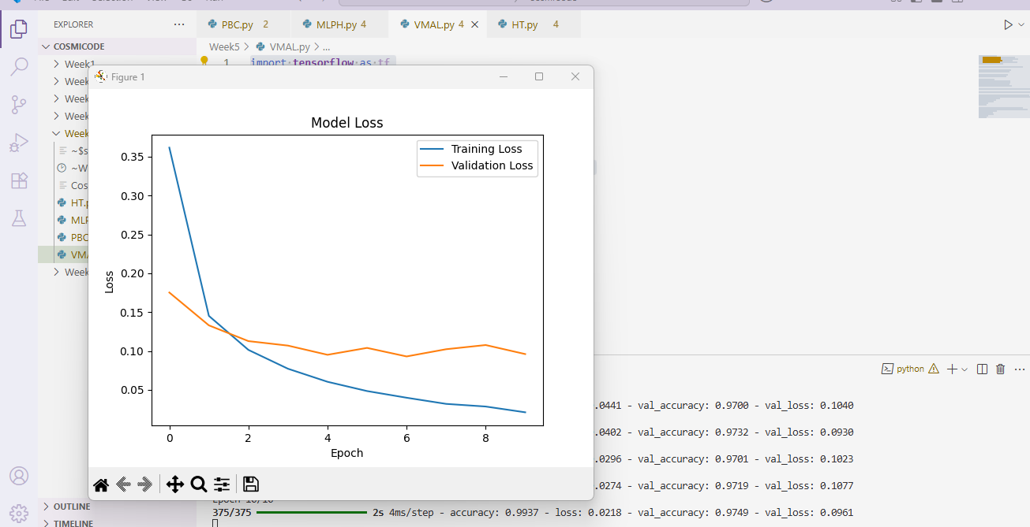
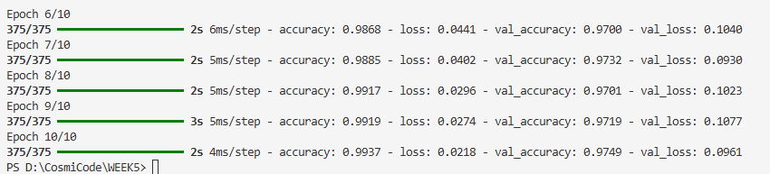

TASK 4:
Perform hyperparameter tuning (change epochs, batch size, activation functions).
SOLUTION:
import tensorflow as tf
from tensorflow.keras.models import Sequential
from tensorflow.keras.layers import Dense, Flatten
from tensorflow.keras.datasets import mnist
from tensorflow.keras.utils import to_categorical
import matplotlib.pyplot as plt

(X_train, y_train), (X_test, y_test) = mnist.load_data()

X_train = X_train.astype('float32') / 255
X_test = X_test.astype('float32') / 255

y_train = to_categorical(y_train, 10)
y_test = to_categorical(y_test, 10)

model = Sequential()
model.add(Flatten(input_shape=(28, 28)))
model.add(Dense(256, activation='tanh'))
model.add(Dense(128, activation='tanh'))
model.add(Dense(10, activation='softmax'))

model.compile(optimizer='adam', loss='categorical_crossentropy', metrics=['accuracy'])

history = model.fit(X_train, y_train, epochs=20, batch_size=64, verbose=1, validation_split=0.2)

plt.plot(history.history['accuracy'], label='Training Accuracy')
plt.plot(history.history['val_accuracy'], label='Validation Accuracy')
plt.title('Model Accuracy')
plt.ylabel('Accuracy')
plt.xlabel('Epoch')
plt.legend()
plt.show()

plt.plot(history.history['loss'], label='Training Loss')
plt.plot(history.history['val_loss'], label='Validation Loss')
plt.title('Model Loss')
plt.ylabel('Loss')
plt.xlabel('Epoch')
plt.legend()
plt.show()

loss, accuracy = model.evaluate(X_test, y_test)
print(f"\nTest Accuracy: {accuracy:.2f}")

OUTPUT:
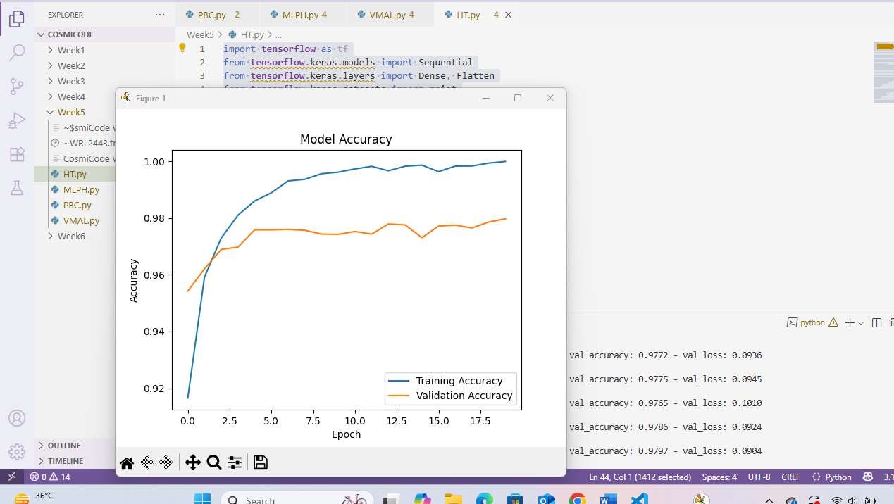
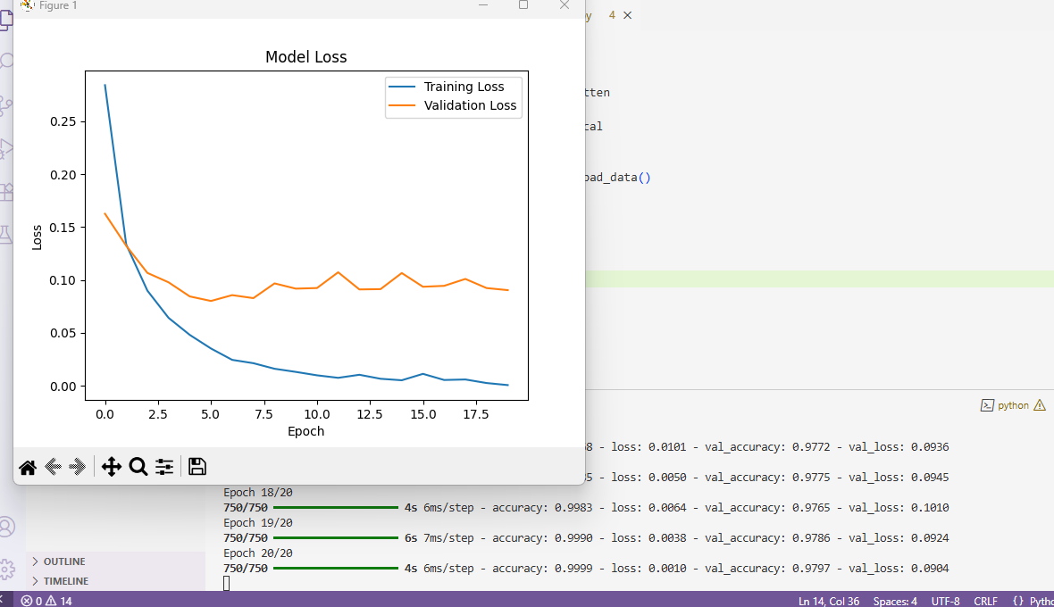
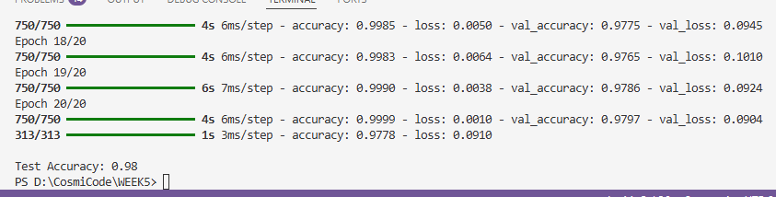

TASK 5:
Write a short blog/note explaining how neural networks learn.
SOLUTION:
Neural networks learn in a way similar to how humans learn from experience. Imagine teaching a child to recognize different objects like apples and oranges. You show them pictures, they guess, sometimes they make mistakes, but with practice, they improve. Neural networks do the same — they are made of layers of small units called neurons that pass information between them. When you give the network some input, like a picture or numbers, it makes a prediction. At first, the prediction might be wrong, but the network compares its guess to the correct answer and calculates the error. It then adjusts its internal connections slightly to reduce that error. This process is repeated many times, with the network continuously improving its predictions. Over time, just like a human gets better at recognizing objects with practice, the neural network becomes more accurate at its task by learning from its mistakes. The more examples you show, the smarter the network becomes.

